**ABHISHEK GARG** 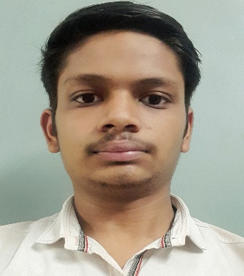

**6395487848 | abhishekgarg73000@gmail.com**

**OBJECTIVE:**

To work in learning and challenging environment, utilizing my skill and knowledge to be the best of my abilities and contribute positively to my personal growth as well as growth of the organization.

**PROFESSIONAL SYNOPSIS:**

* Language knowledge of **C, Java.**
* Can work with **HTML, CSS, JAVASCRIPT, SQL.**
* Good knowledge of **Data Structure.**
* Good knowledge of **DBMS.**
* Always interested in learning emerging technology.

**PROJECTS:**

**1) Hospital Management System**

**Based on -** Java

**2) ChatBuddy –A Social Networking Site**

**Technology Used:** MERN Technology

**Role:** Backend developer

**Team Member:**3

**SCHOLASTICS:**

* **Masters of Computer Applications** from Ajay Kumar Garg Engineering College, Ghaziabad in 2021-2023.
* **Bachelor of Computer Application** from Shri Ram college, Muzaffarnagar in 2018-2021 with **74.5%.**
* **12th(P.C.M.)** from C.B.S.E Board in 2018 with aggregate percentage **70.33%.**
* **10th** from C.B.S.E Board in 2016 with aggregate percentage **8.4 CGPA.**

**INTEREST & HOBBIES:**

Playing Chess and Cricket etc.

**PERSONAL DETAILS:**

* **Name**: Abhishek Garg
* **Date of Birth**: 07 May 2002
* **Marital Status**: Single
* **Address**: 154, Moh. Bhatwara, Budhana, Muzaffarnagar
* **Mob No.**: 6395487848
* **Email**: [abhishekgarg73000@gmail.com](mailto:abhishekgarg73000@gmail.com)
* **LinkedIn**: <https://www.linkedin.com/in/abhishek-garg-603317228/>
* **HackerRank** : <https://www.hackerrank.com/abhishekgarg2511>
* **CodeChef** : <https://www.codechef.com/users/abhishekgarg02>

I hereby declare that the mention information is correct up to my Knowledge and I bear the responsibility for the correctness of the mentioned particular.

**Place: Ghaziabad (Abhishek Garg)**